|  |  |
| --- | --- |
|  | FH-Series |
|  | Release Notes |
|  | Firmware v3.0.0.12 |



© 2024 Teledyne FLIR LLC All rights reserved worldwide. No parts of this manual, in whole or in part, may be copied, photocopied, translated, or transmitted to any electronic medium or machine readable form without the prior written permission of Teledyne FLIR LLC.

Names and marks appearing on the products herein are either registered trademarks or trademarks of Teledyne FLIR LLC and/or its subsidiaries. All other trademarks, trade names, or company names referenced herein are used for identification only and are the property of their respective owners.

This product is protected by patents, design patents, patents pending, or design patents pending.

Photographs and images appearing in this manual may have been modified for illustrative purposes using commercial image editing software and may not always reflect an actual product configuration.

The contents of this document are subject to change without notice.

For additional information visit [www.flir.com](http://www.flir.com) or write to Teledyne FLIR LLC

Teledyne FLIR LLC

Antennvägen 6

PO Box 7376

SE-187 15 Täby Stockholm County

187 66

Sweden

Support: <https://support.flir.com/>

**Document History**

|  |  |  |
| --- | --- | --- |
| Revision | Date | Comment |
| 100 | March 17, 2022 | v2.0.0.46 Initial FLIR release |
| 110 | June 26, 2023 | v2.0.0.52 |
| 120 | September 21, 2023 | v2.0.0.60 |
| 130 | November 2, 2023 | v2.0.0.66 |
| 140  150 | May 15, 2024  October 2, 2024 | v3.0.0.9  v3.0.0.12 |

Table of Contents

1 Version Content 4

1.1 Firmware Version Details and Download Locations 4

1.2 DNA Tool 4

2 Supported Products and Platforms 5

3 Upgrading the Camera Firmware 6

4 Fixed Issues 8

5 Known Issues and Limitations 9

6 Disclaimer 10

# Version Content

This release supports the fixed issues listed in section 4. These release notes also document Supported Products and Platforms, Upgrading the Camera Firmware, and Known Issues and Limitations.

## Firmware Version Details and Download Locations

|  |  |
| --- | --- |
| Firmware | V3.0.0.12 |
| Download URL | [FHSeriesv3012](https://teledyne.box.com/s/m62r3p1smvzcau5y7o2asedi0weu2j3l) |

## DNA Tool

Download FLIR DNA (Discovery Network Assistant) from [here](https://teledyne.app.box.com/s/qbc5ag0sf4vaeyhmbj1n8jy18ms8telx/folder/58739581413) ([https://flir.box.com/s/DNA](https://teledyne.app.box.com/s/qbc5ag0sf4vaeyhmbj1n8jy18ms8telx/folder/58739581413)).

|  |
| --- |
| Q:\Multi-Camera Library\Shared files\caution symbol.PNG **Important** |
| DNA v2.3.0.33 and later fully support cameras. Earlier DNA versions do not. |

# Supported Products and Platforms

This release supports:

|  |  |
| --- | --- |
| **Product/Platform Name** | **Description** |
| FH-Series ID | Fixed-mount IP visible & thermal security camera with onboard video analytics |
| FH-Series R | Fixed-mount IP visible & thermal security camera with onboard video analytics and radiometry |
| FH-Series R PTZ | Pan-Tilt Zoom IP visible & thermal security camera with onboard radiometry |
| FLIR Discovery Network Assistant | Version 2.3.0.33 and 2.3.0.35 |
| Web browsers | Google Chrome Version 128.0.6613.138 (Official Build) (64-bit)  Firefox 126.0.1 (64-bit) |
| United VMS | Latitude version 9.2.3 |
| Third-party VMSs | Avigilon, exacqVision, Genetec, and Milestone XProtect |
| ONVIF® Test Tool | Version 24.06 rev. 212 |

|  |
| --- |
| **Note** |
| Do not use this firmware version in any other device or for any other purpose. |

# Upgrading the Camera Firmware

Before upgrading the camera firmware, download it from the Firmware Location.

To upgrade the camera firmware, you can use v2.3.0.33 of the DNA tool or the camera’s web page. For information about how to upgrade the firmware using camera’s web page, see the camera’s installation and user guide.

To upgrade the camera’s firmware using the DNA tool:

1. Open the DNA tool and select the camera(s) you are upgrading from the Discover List.

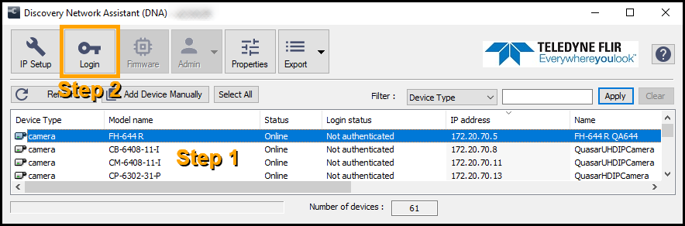

1. Authenticate the camera.
   1. Click **Login**.
   2. In the **DNA - Login** window, make sure *admin* is the User Name, type the password for the admin user (default: *admin*), and then click **Login**.

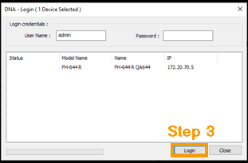

* 1. After the Status becomes **OK**, click **Close**. In the Discover List, the camera login Status is now *Authenticated*.

1. From the Discover List, select the camera again and click **Firmware**.
2. In the **Update Firmware** window, click **Browse**, and then select the firmware upgrade file.

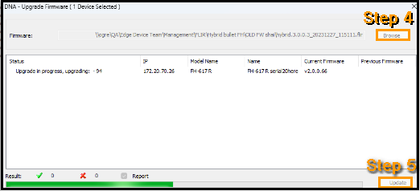

1. Click **Update**.

# Fixed Issues

This release fixes the following issues from v3.0.0.9:

|  |  |
| --- | --- |
| **Summary** | **Comment** |
| When using Fusion analytics, the min/max width and height are not saved after upgrading to new firmware. |  |
| If a user changes the "Background Heater Control" to AUTO on the Heaters and Fans page and then upgrades the firmware, the "Background Heater Control" changes back to OFF after the upgrade. |  |
| Changes were made to the DDR settings to optimize CV2 SOM |  |
| On the Radiometry page, the parameter "Hysteresis time" is not saved after a reboot. |  |
| When a recording is started through ONVIF and stopped, the recording stream is not stopped. |  |
| Defining motion as “Radiometric Alarm Notification" in ONVIF is not saved when the firmware is upgraded. |  |
| The camera shows the wrong status after an SD card is inserted. |  |
| The heater settings are not saved when firmware is upgraded from 1.0.0.13 to 3.0.0.6 |  |
| The PAL analog out video is corrupted/disrupted. |  |

# Known Issues and Limitations

When upgrading from v3.0.0.x to firmware v3.0.0.12, **partial reset** is necessary to preserve network configuration settings. The password should be reset in a secure network.

|  |  |
| --- | --- |
| **Summary** | **Comment** |
| On the visible tab, Contrast is not working (FH-PTZ it is ok). |  |
| Manual white balance: One push trigger not making color balance, instead it is making focus. |  |
| OSD > AV > PAL > visible > OSD is cut in half. |  |
| FH PTZ only > Boresight calibration is not saved after factory reset. |  |
| Analog video source > The thermal video is not smooth. |  |
| SOE of Thermal is not downloaded when both Visible and Thermal are enabled to download SOE. |  |
| Hybrid Bullet with QVGA Sensor > poor detection performance. |  |
| Video Analytics - The analytics recognizes cars as humans. Additionally, we get false alerts on trees. |  |
| Stopped track vehicle VA OSD removed in additional 15 seconds. |  |
| On the radiometry page, using the car detection filter, the radiometry box does not detect cars, only changes to red. |  |
| On the Radiometry page, the OSD overlay can hide the box or spot. |  |
| On the Radiometry page, the radiometric item Diff is not showing on the OSD. |  |
| FH - PTZ - Because of the structure of the camera + addition of a motor, the camera cannot support these features: I/O, Audio in/out, Analog out. |  |
| In Latitude, Radiometry Events, alert number 0 is not shown in Latitude. |  |
| Latitude Actions - "Radiometric alarm triggered" events are limited to 4 triggers max, even though the camera can support 25 triggers. |  |
| Cyber Security - Avoid transmitting in clear text for adding users or changing passwords (Critical). |  |
| Cyber Security - Slowloris and Slow POST Attacks (Critical). |  |
| SSH Terrapin Prefix Truncation Weakness – ONLY AFFECTED DEBUG (Medium). |  |
| Cyber Security - Upgrade Dropbear to version 2024.84 (Minor). |  |
| Cyber Security - Upgrade Nginx to version 1.26.0 (Minor). |  |
| Port forwarding/DMZ/VPN - Does not work. |  |

# Disclaimer

By providing this document, Teledyne FLIR LLC is not making any representations regarding the correctness or completeness of its contents and reserves the right to alter this document at any time without notice.

© Teledyne FLIR LLC 2024. All rights reserved.

**Teledyne FLIR LLC**

Antennvägen 6

PO Box 7376, SE-187

15 Täby

Stockholm County, 187 66

Sweden

Support:

<https://support.flir.com/>